IIT JEE 2009 Chemistry Paper1 Solutions
______________________________________________________________________
SINGLE CORRECT CHOICE TYPE
1. The Henry's law constant for the solubility of N₂ gas in water at 298 K is 1.0 × 10⁵ atm. The mole fraction of N₂ in air is 0.8. The number of moles of N₂ from air dissolved in 10 moles of water at 298 K and 5 atm pressure is
(A) 4.0 × 10⁻⁴
(B) 4.0 × 10⁻⁵
(C) 5.0 × 10⁻⁴
(D) 4.0 × 10⁻⁶

Sol. (A)
According to Henry's law
P = KH Χ_{N2}
0.8 × 5 = 1 × 10⁵ × Χ_{N2}
Χ_{N2} = 4 × 10⁻⁵ (in moles of water)
Þ 4 × 10⁻⁵ = η _{N2} / (η _{N2} + 10)
η _{H2} × 5 × 10⁻⁵ + 4 × 10⁻⁴ = η _{H2}
=> η _{H2} = 4 × 10⁻⁴

2. The correct acidity order of the following is

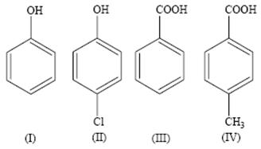

(A) (III) > (IV) > (II) > (I)
(B) (IV) > (III) > (I) > (II)
(C) (III) > (II) > (I) > (IV)
(D) (II) > (III) > (IV) > (I)

Sol. (A)

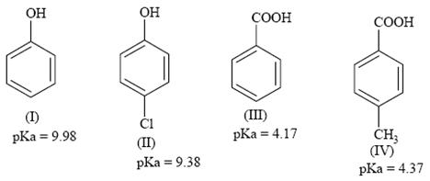

The electron withdrawing group increases acidity and electron donating group decreases acidity.
Decreasing order of acidic strength: III > IV > II > I
3. The reaction of P₄ with X leads selectively to P₄O₆. The X is
(A) Dry O₂
(B) A mixture of O₂ and N₂
(C) Moist O₂
(D) O₂ in the presence of aqueous NaOH

Sol. (B)
N₂
P₄ + 3O₂ --------------> P₄O₆ (exclusively)
(N₂ is used to retard the further oxidation)

4. Among cellulose, poly(vinyl chloride), nylon and natural rubber, the polymer in which the intermolecular force of attraction is weakest is
(A) Nylon
(B) Poly (vinyl chloride)
(C) Cellulose
(D) Natural Rubber

Sol. (D)
The chain of natural rubber involves weak Vander Waal's force of interaction.

5. Given that the abundances of isotopes ⁵⁴Fe, ⁵⁶Fe and ⁵⁷Fe are 5%, 90% and 5% respectively, the atomic mass of Fe is
(A) 55.85
(B) 55.95
(C) 55.75
(D) 56.05

Sol. (B)
A⁻ = ∑ A_{i}X_{i}/∑ X_{i}
A⁻ = 54 × 0.05 + 56 × 0.90 + 57 × 0.05 (where A⁻ is atomic mass of Fe)
A⁻ = 55.95

6. The IUPAC name of the following compound is
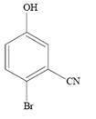
(A) 4-Bromo-3-cyanophenol
(B) 2-Bromo-5-hydroxybenzonitrile
(C) 2-Cyano-4-hydroxybromobenzene
(D) 6-Bromo-3-hydroxybenzonitrile

Sol. (B)
The CN group has a higher priority over the OH and Br group.

7. Among the electrolytes Na₂SO₄, CaCl₂, Al₂(SO₄)₃ and NH₄Cl, the most effective coagulating agent for Sb₂S₃ sol is
(A) Na₂SO₄
(B) CaCl₂
(C) Al₂(SO₄)₃
(D) NH₄Cl

Sol. (C)
As Sb₂S₃ is a negative sol, so, Al₂(SO₄)₃ will be the most effective coagulant due to higher charge density on Al³⁺ in accordance with hardy-Schulze rule.
Order of effectiveness of cations: Al³⁺ > Ca⁺⁺ > Na⁺ > NH
8. The term that corrects for the attractive forces present in a real gas in the Vander Waals equation is
(A) nb
(B) an²/V²
(C) - an²/V²
(D) -nb

Sol. (B)
In the given Vander Waals equation:
(P + n² a/V² )(V - nb) = nRT

The measure of force of attraction for 'n' moles of real gas is given by n² a/V²

MULTIPLE CORRECT CHOICE TYPE
9. The compound(s) formed upon combustion of sodium metal in excess air is (are)
(A) Na₂O₂
(B) Na₂O
(C) NaO₂
(D) NaOH

Sol. (A, B) in dry air. Sodium metal do not for super oxide.

10. The correct statement(s) about the compound
H₃C(HO)HC-CH=CH-(OH)CH₃ (X) is(are)
(A) The total number of stereoisomer
(B) The total number of diastereomers possible for X is 3
(C) If the stereochemistry about the double bond in x is trans, the number of enantiomers possible for X is 4
(D) If the stereochemistry about the double bond is X is cis, the number of enantiomers possible for X is 2

Sol. (A, D)

11. The compound(s) that exhibit(s) geometrical isomerism is (are)
(A) [Pt(en)CI₂]
(B) [Pt(en)₂]CI₂
(C) [Pt(en)₂CI₂]CI₂
(D) [Pt(NH₃)₂CI₂]

Sol. (C, D)
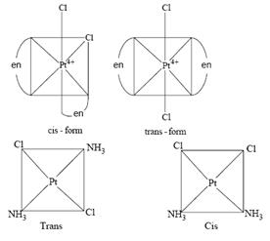

12. The correct statement(s) regarding defects in solids is(are)
(A) Frenkel defect is usually favoured by a very small difference in the sizes of cation and anion
(B) Frenkel defect is a dislocation defect
(C) Trapping of an electron in the lattice leads to the formation of F-center
(D) Schottky defects have no effect on the physical properties of solids

Sol. (B, C)
Frenkel defect is favoured when the difference in the size of one cation and anion is quite large. Schottky defect decreases density of the solid.

COMPREHENSION TYPE
A carbonyl compound P, which gives positive idoform test, undergoes reaction with MeMgBr followed by dehydration to give an olefin Q. Ozonolysis of Q leads to a dicarbonyl compound R, which undergoes intramolecular aldol reaction to give predominantly S.
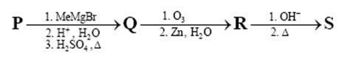

13. The structure of the carbonyl compound P is
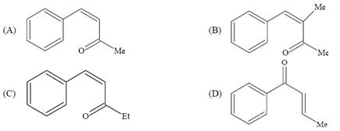

Sol. (B)

14. The structure of the products Q and R, respectively are
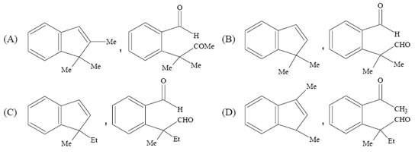

Sol. (A)
15. structure of the product S is
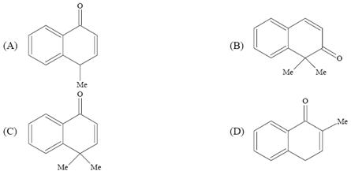

Sol. (B)
Solution for the question nos. 13 to 15
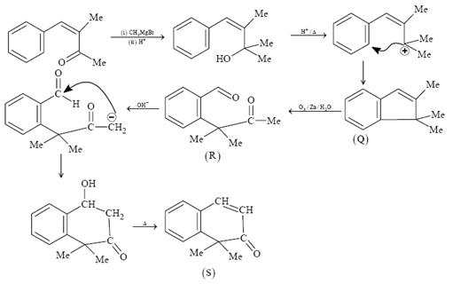

Paragraph
p-Amino-N, N-dimethylaniline is added to a strongly acidic solution of X. The resulting solution is treated with a few drops of aqueous solution of Y to yield blue colouration due to the formation of methylene blue. Treatment of the aqueous solution of Y with the reagent potassium hexcyanoferrate (II) leads to the formation of an intense blue precipitate. The precipitate dissolves on excess addition of the reagent. Similarly, treatment of the solution of Y with the solution of potassium hexacyanoferrate (III) leads to a brown colouration due to the formation of Z.

16. The compound X is
(A) NaNO₃
(B) NaCl
(C) Na₂SO₄
(D) Na₂S

Sol. (D)

17. The compound Y is
(A) MgCI₂
(B) FeCI₂
(C) FeCI₃
(D) ZnCI₂

Sol. (C)
18. The compound Z is
(A) Mg₂[Fe(CN)₆]
(B) Fe[Fe(CN)₆]
(C) Fe₄[Fe(CN)₆]₃
(D) K₂Zn₃[Fe(CN)₆]₂

Sol. (B)
Solution for the question nos. 16 to 18
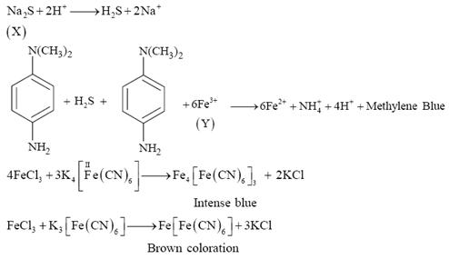
(X) - Na₂S
(Y) - FeCI₃
(Z) - Fe[Fe(CN)₆]

Matrix Match Type
19. Match each of the compounds in Column I with its characteristic reaction(s) in Column II.
Column I |  | Column II
(A) | CH₃CH₂CH₂CN | (p) | Reduction with Pd-C/H₂
(B) | CH₃CH₂OCOCH₃ | (q) | Reduction with SnCI₂/HCI
(C) | CH₃-CH=CH-CH₂OH | (r) | Development of foul smell on treatment with chloroform and alcoholic KOH
(D) | CH₃CH₂CH₂CH₂NH₂ | (s) | Reduction with diisobutylaluminium hydride (DIBAL-H)
 |  | (t) | Alkaline hydrolysis
Sol. (A - p, q, s, t) (B - s, t) (C - p) (D - r)

20. Match each of the diatomic molecules in Column I with its property/properties in Column II.
Column I |  | Column II
(A) | B₂ | (p) | Paramagnetic
(B) | N₂ | (q) | Undergoes oxidation
(C) | O₂⁻ | (r) | Undergoes reduction
(D) | O₂ | (s) | Bond order > 2
 |  | (t) | Mixing of 's' and 't' orbitals
Sol (A - p, r, t), (B - s, t), (C - p, q), (D - p, q, s)

